The International Workshop on UI GreenMetric Sustainable University Rankings (IWGM) 2026

Title (Capitalize Each Word, Calibri, 18pt, spacing 1)

Author name*¹, Author name ², Author name ³ (Calibri, 12 pt, italic)

¹Institution, Country (Calibri, 10 pt, italic)
²Institution, Country (Calibri, 10 pt, italic)
³Institution, Country (Calibri, 10 pt, italic)
*corresponding author: email (Calibri, 10pt)

Abstract. The abstract title is written in Calibri style (14 pt and bold). The body text of the abstract was written Calibri style (10 pt). An abstract should inform the prospective reader of what you did and highlight the key findings. Avoid using technical jargon and uncommon abbreviations. The abstract should be clear, concise, and descriptive. Abstracts at least include research background (not mandatory except in the field of health sciences), study objectives, brief methods, brief findings, and brief conclusions. The abstract should end with a comment on the significance of the results or a brief conclusion. Please follow word limitations (100‐300 words).
Keyword:
Keywords written under the abstract text are arranged in alphabetical order and separated by a comma. Title keywords are written with Calibri style with 14 pt bold font while the keywords written with Calibri 10 pt.

- Introduction
The introduction must contain the state of the art from previous studies, there is a gap analysis/gap analysis/statement of novelty/statement of contribution to the novelty of the article.
Full paper is expected to focus on sharing best practices in campus sustainability, as well as showcasing innovative policies and programs implemented at your institution. Papers should be aligned with one or more of the seven UI GreenMetric criteria: Setting and Infrastructure, Energy and Climate Change, Waste, Water, Transportation, Education and Research, as well as Governance and Digitalization. However, authors are required to select one primary theme that is most strongly emphasized in their paper.

- Theoretical Approach/Methodology/Scenario
Articles should be written on A4 paper (210 x 297 mm). Articles are written without page numbers and arranged in the following order: Title, Abstract, Keywords, Introduction, Theoretical Approach/Methodology/Scenario, Results/Discussion/implementation, Conclusions / Summary/ Future Perspectives, Acknowledgments (if any), Notation List (if any) and References.
The article begins with the title of the article written in font Calibri, 18 pt bold. The title is an opportunity to attract the reader’s attention. Remember that readers are the potential authors who will cite your article. Identify the main issue of the paper. The title should be accurate, unambiguous, specific, and complete. Do not contain infrequently-used abbreviations.
The author's name is written under the title in font Calibri, 12 pt italic. The author's name is written completely without an academic degree. Apostrophes are written behind the author's name in superscript format. The name of the institution (institution, and country) is written under the author's name with the theme of Calibri 10 pt, italic. If the author is more than one, should be a written email for the correspondence author (corresponding author). The article title, author's name, and institutional name are written flat center.
The contents of the article are written with a left margin of 2,54 cm, a right margin of 2,54 cm, a bottom margin of 2,54 cm, and a top margin of 2,54 cm. The header distance from the edge of the paper is 1,25 cm, and the footer distance from the edge of the paper is 1,25 cm. Articles are written in MS Word program with Calibri font type, 12 pt font, 1 space, and in one column format written justified.
Subtitles are written in bold with Capitalize Each Word format and arranged to align left with a number and no underscore. Sub subtitles are written in bold with Sentence case format and arranged to align left with no number and underscore.

- Results/Discussions/Implementation
Figures and Tables
Figures and Tables are placed in groups of text and annotated. The figure is followed by the caption placed under the figure and the table is followed by the caption placed on the table. The figures and the tables are numbered. The figure is guaranteed to be printed clearly even though it is reduced to 50%. The figure is not framed. Tables with no vertical lines, whereas horizontal lines are only shown in 3 main horizontal lines i.e., 2 horizontal lines for the column headings and 1 closing line for the bottom row.
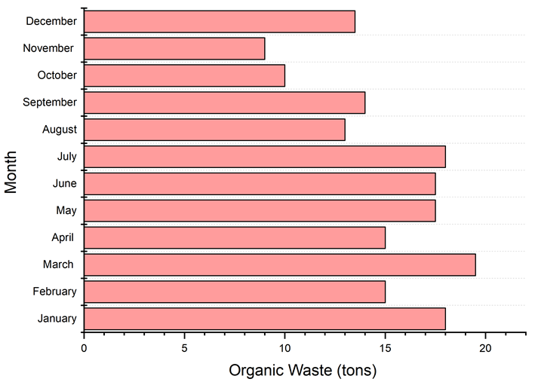
Figure 1. University of Babylon rank for each indicator (2017-2020)

Table 1. Quantity of Solid Waste Generated
S.No. | Name of the waste material | Weight (kg/day)
1 | Plant Residue | 692
2 | Vegetable Waste | 290
3 | Wood Materials | 43
Total |  | 1025

Equations
The equations are written center and numbered in parentheses. The number is placed at the end of the right margin of the column.

$D=\frac{A}{{\left(V_{rel}^{2}ρ_{a}\right)}^{2}}+B{\left(\frac{M_{air}}{M_{liq}}\right)}^{-β}$ (1)

Quote Writing
The writing system quotes a manuscript or literature using the Vancouver system. Examples: These results clearly indicate that the University of Babylon is moving at a steady and confident pace in order to achieve its vision, mission, and goals outlined in its strategic plan for 2018-2022 [1]

- Conclusions/Summary/Future Perspectives
Conclusions/Summary/Future Perspectives should only answer the objectives of the research. Tells how your work advances the field from the present state of knowledge. Without clear Conclusions/Summary/Future Perspectives, reviewers and readers will find it difficult to judge the work, and whether or not it merits publication in the journal. Do not repeat the Abstract, or just list experimental results. Provide a clear scientific justification for your work, and indicate possible applications and extensions. You should also suggest future experiments and/or point out those that are underway. Conclusions/Summary/Future Perspectives may not use bullets and numbering.

Acknowledgment
The authors gratefully acknowledge the support of [funding agency/institution name] under grant number [XXXXXX]. We also thank [individuals, research assistants, or laboratories] for their contributions to [specific help such as analysis, equipment use, field assistance, etc.].

Conflict of Interest
The authors declare that there is no conflict of interest regarding the publication of this paper. Alternatively, if a conflict exists: The authors declare the following conflicts of interest: [describe the nature of the conflict].

Authors Contribution
The Authors’ Contribution section should be written in paragraph form and must clearly specify the role of each author in the completion of the research and manuscript. Each author should be referred to by their initials, as listed in the author byline. The paragraph should describe specific contributions such as conceptualization, methodology, data collection, analysis, manuscript writing, review, supervision, or funding acquisition. It is recommended to use standardized contribution terms based on the CRediT taxonomy to ensure clarity and consistency. The statement should reflect an honest and accurate description of individual contributions, and must be approved by all authors prior to submission. Avoid using bullet points or tables, and ensure that every author’s role is acknowledged appropriately within the narrative. All authors contributed substantially to the work. A.B. conceived the research idea and designed the methodology. C.D. carried out the experiments and data collection. E.F. conducted the data analysis and interpretation. G.H. contributed to the manuscript writing and critical revision. All authors reviewed and approved the final version of the manuscript.

References
All manuscripts submitted to the Journal of Sustainability Perspectives must use the Vancouver referencing style, a numeric citation system in which sources are cited in the text by number, in the order in which they appear. Each number corresponds to a full citation in the reference list at the end of the manuscript. Authors are encouraged to use Mendeley Reference Manager and choose the “Vancouver” citation style to ensure formatting consistency and ease of citation during drafting and revision.
In-text Citation Rules, cite sources using brackets (e.g., [1]). Using commas to separate multiple non-consecutive citations: [2,4,6] and using a hyphen for citation ranges: [3–5].
Reference List Rules, list references numerically in the order cited, not alphabetically. Use author names in the format: Last name, followed by initials without punctuation (e.g., Hasan MM, not Hasan, M.M.). Use a period (.) after journal abbreviations and initials. Include up to six authors; for more than six, list the first six followed by “et al.” Use official journal abbreviations (e.g., Sustain Sci, not Sustainability Science), as found in the NLM Catalog. Use sentence case for article and chapter titles (capitalize only the first word and proper nouns). Use en dashes (–) for page ranges, not hyphens. Do not italicize journal names, article titles, or book titles. References are listed with numbers and references should be minimum 15 references.
- Hasan MM, Rahman M, Hoque A. Renewable energy, climate change and sustainable development: A review. Sustainability. 2022;14(4):2183.
- Sachs JD. The age of sustainable development. New York: Columbia University Press; 2015.
- Lele S. Environment and well-being: engaging with the SDGs. In: Khosla R, editor. Rethinking sustainability pathways. London: Routledge; 2021. p. 103–120.
- Nugroho Y, Setiawan D. Integrating circular economy in urban development planning. In: Proceedings of the 4th International Conference on Sustainable Development; 2023 Sep 20–22; Yogyakarta, Indonesia. Jakarta: SD Conference Press; 2024. p. 88–96.
- United Nations. The 2030 Agenda for Sustainable Development [Internet]. New York: United Nations; 2015 [cited 2025 Jul 20]. Available from: https://sdgs.un.org/2030agenda

